A Brief Introduction to Brackets

For a large part of this module, where it is necessary to write HTML and CSS code, we are going to be using a program called Brackets. Brackets has been written by Adobe and is an active, ongoing project. It is free to download if you wish to use it at home or on your laptop from <http://www.brackets.io>.

# First use

When Brackets is first opened, it displays the code for a ‘Getting Started’ guide. This is an excellent guide and I recommend you spend ten or so minutes reading it in a moment or after this introduction.

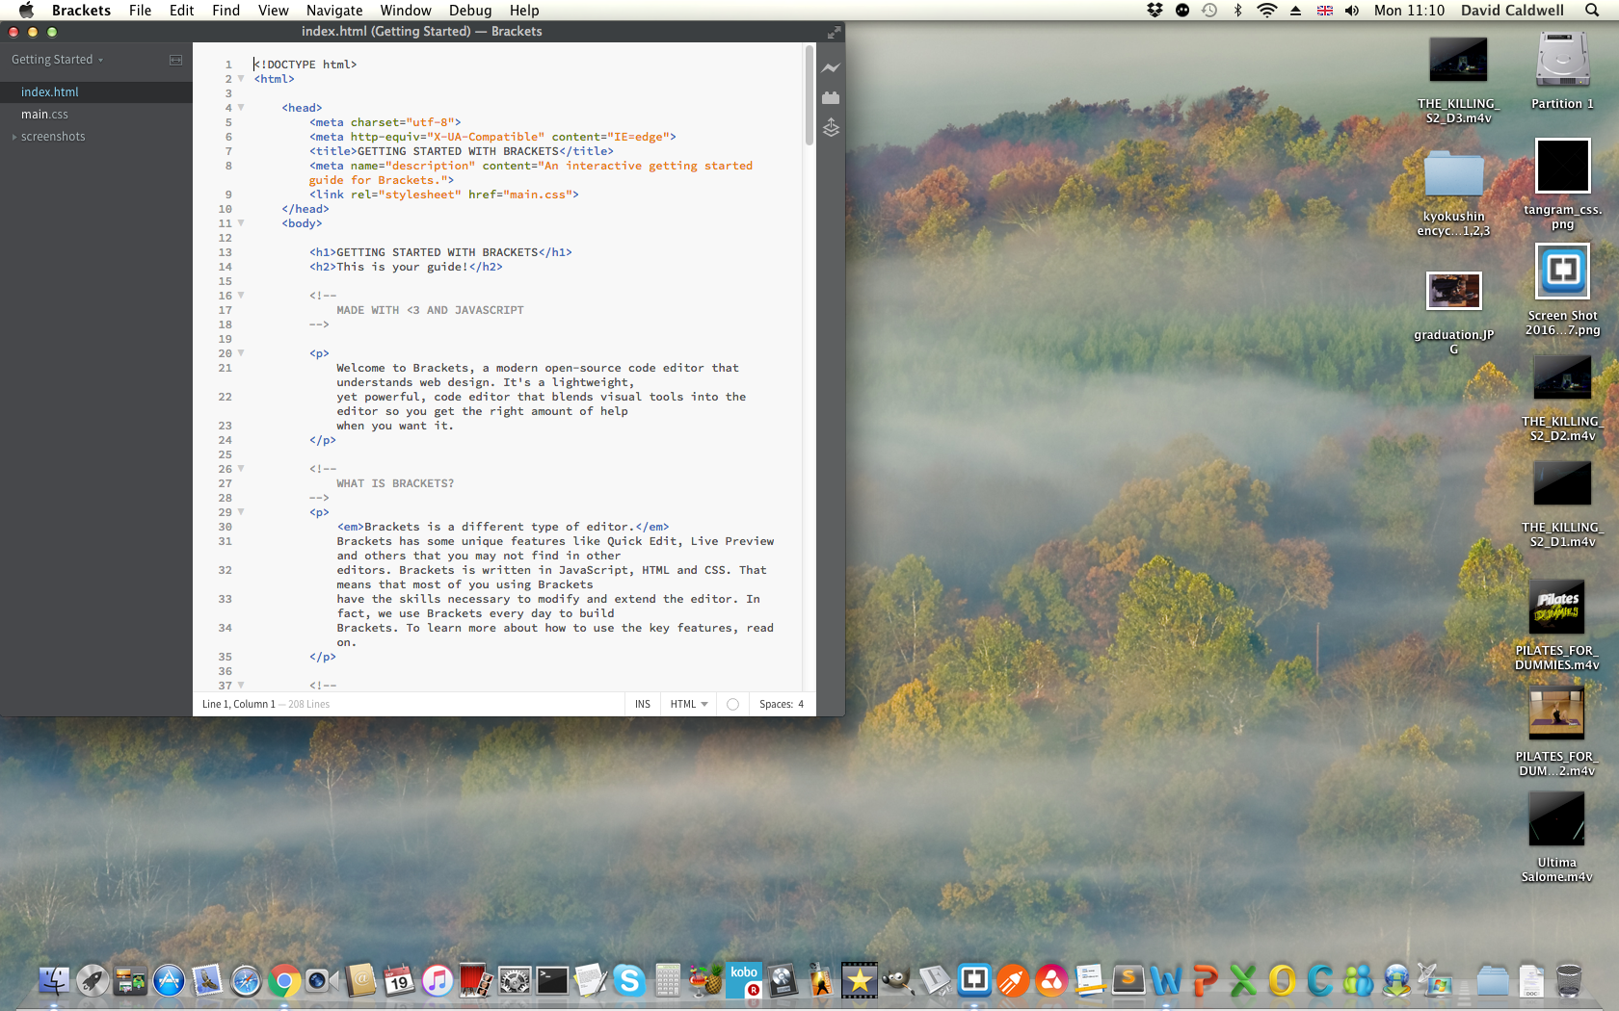

Toolbar

Side

Panel

Main

Window

The main parts of Brackets that I want to point out are its main window, the side panel and the toolbar.

As I’m sure your suspect, your code is typed in the large main window. The file you are currently working on is selected in the side panel on the left-hand side (more on this in a moment).

The toolbar on the right houses the ‘Live Preview’ button (the one that looks like a lightning flash). Live Preview is incredibly useful: it allows you to see your code take effect in a web browser as you type. Try clicking it to sure it works. The icon should turn yellow and a browser window should launch. This is an essential part of Brackets so let someone know if it doesn’t work.

**It is important to remember that you may need to save the file you are working on before the browser preview is updated.**

# A note about the side panel

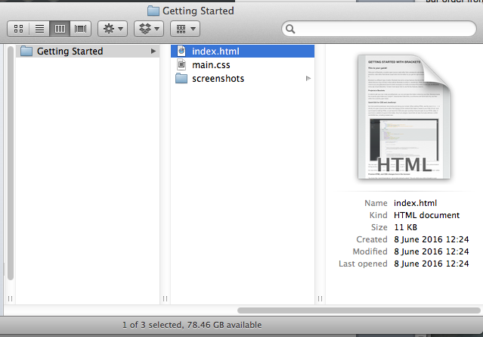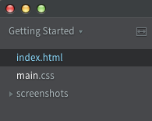The side panel can be confusing. But, put simply, it shows you a folder and its contents. Using the default ‘Getting Started’ website as an example, if we browse to where the ‘Getting Started’ project is stored, we would find a folder structure and a set of documents that mirrors the side panel list exactly.

## Starting your own project

If you click on the dropdown arrow next to the text ‘Getting Started,’ you will be presented with an option to ‘Open Folder…’ If you have previously created websites in Brackets, they will be listed below this option.

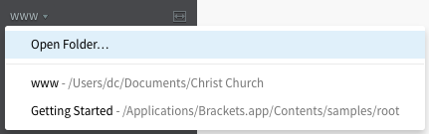

To create a new website, click ‘Open Folder…’ Now choose the location you want your website to reside in and click ‘New Folder.’ Give your website a title and click ‘Open.’ If you browse the file system to this location, you should see the website folder you just created. Files for this website will appear here. (You can open existing websites by browsing to the root folder of the website in question after clicking ‘Open Folder.’)

There is nothing mysterious or hidden in the way that Brackets operates: it transparently uses the operating system folder and file structure. This means that you can simply copy your website folder somewhere else (another machine, a web server, etc.) and the integrity of your website will be maintained.

# Recommendation

For each website (even if it is small), I recommend creating a new folder using a logical scheme that makes sense to you – perhaps with a date included in the title to give yourself context when looking through previous work.